Jonathan Oen

PID: A14547654

**ECE 115 Module 2**

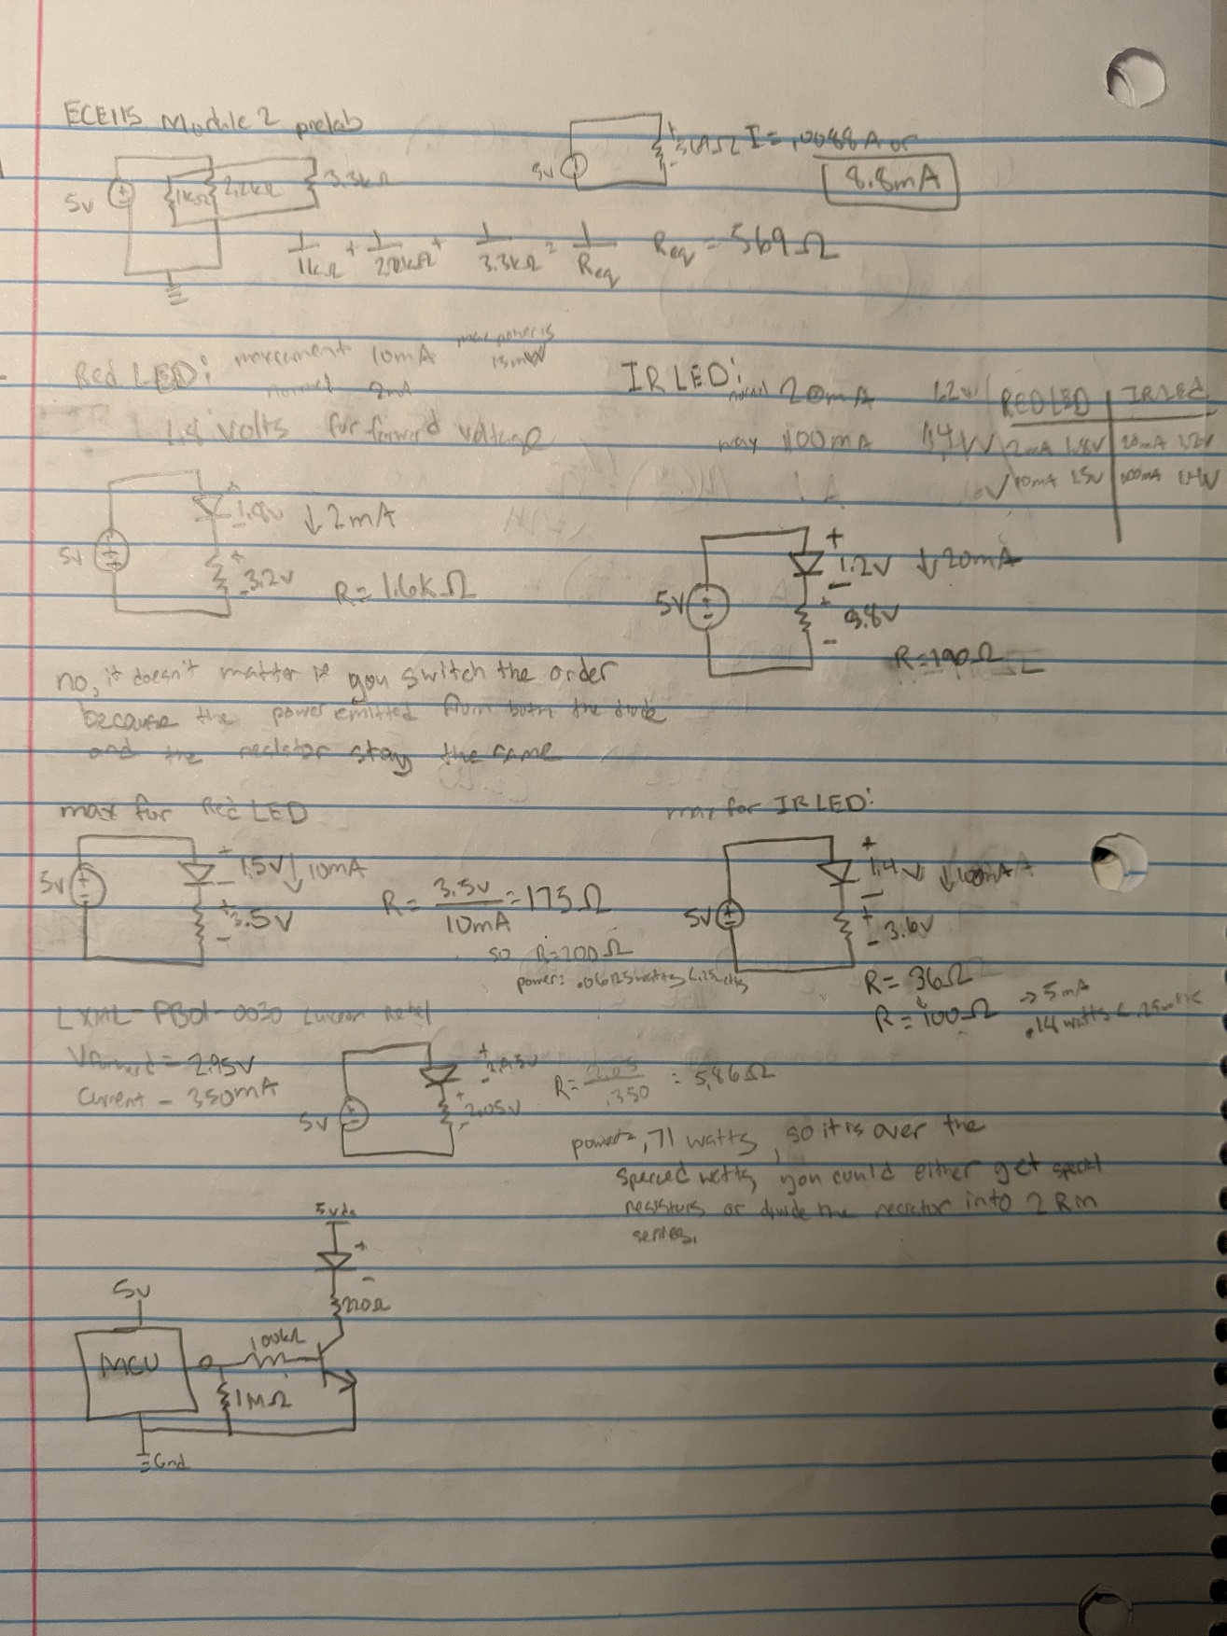

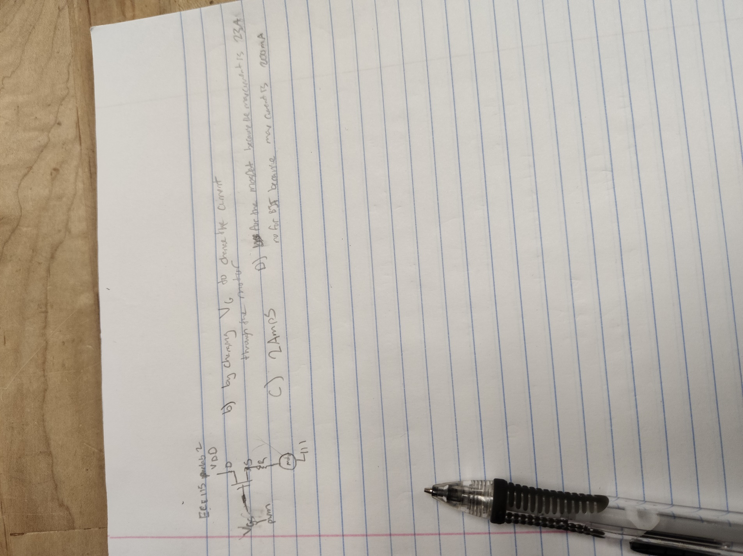

**2.3.3.b MOSFET DC motor controller**

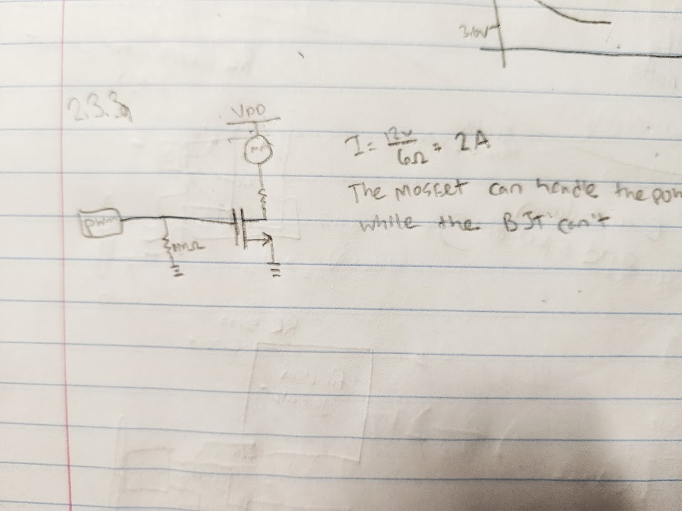

**2.3.3.c.1 MOSFET solenoid driver**

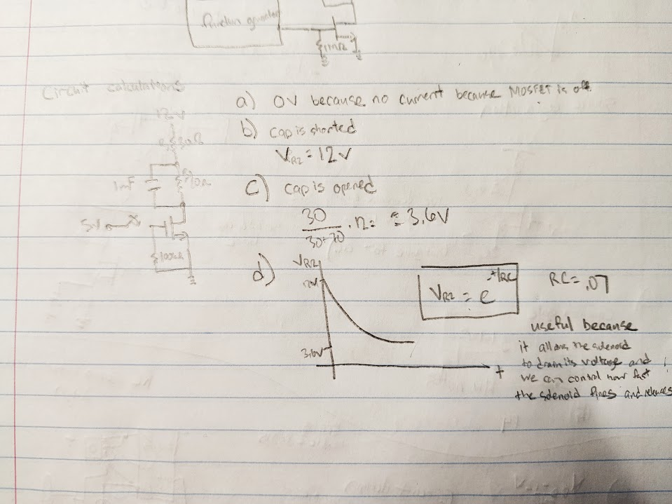

**2.3.3.c.2 MOSFET Solenoid circuit**

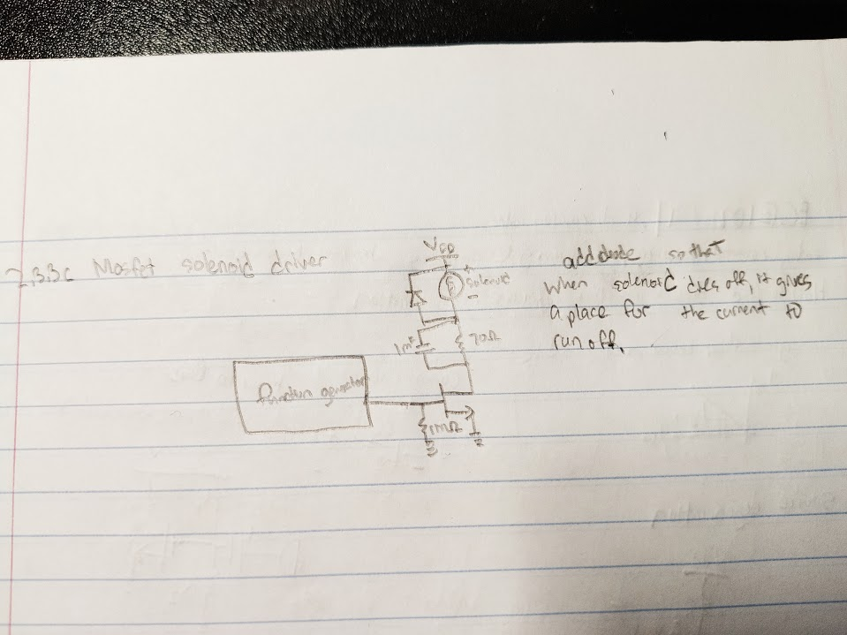

**2.3.3.d RC servo motor control**

Preliminary circuit design

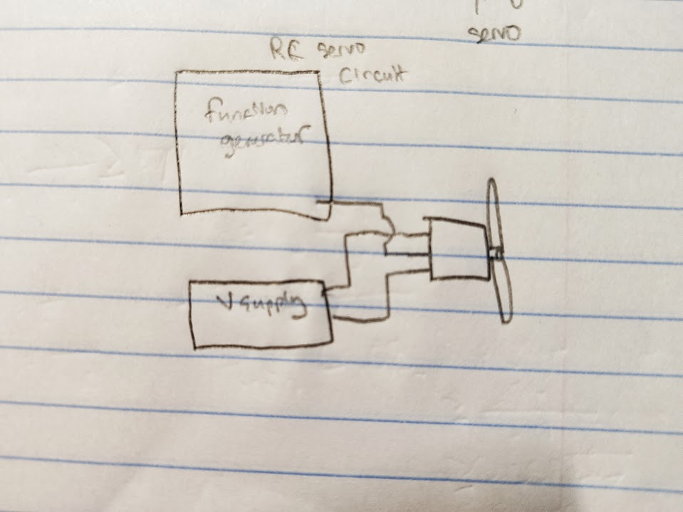

Description of the circuit parameters

The frequency used to control the position of the servo motor is 1khz and changed the duty cycle on the wave to control the exact position of the servo motor.

We connected the voltage rail to the high-load supply or 5v because this input is simply used to power the servo motor.

**2.3.4 Arduino Programming Exercises**

(shown to TA)

**2.3.5 Pinball motor (RC Servo design) design Cycle**

Circuit Diagram refer to 2.3.3.d

**Sketch**

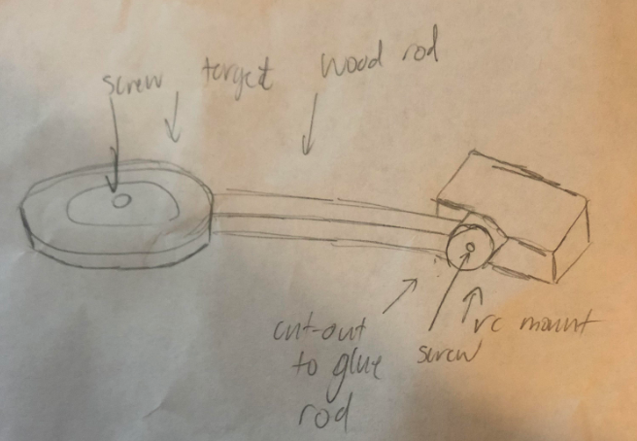

**CAD**

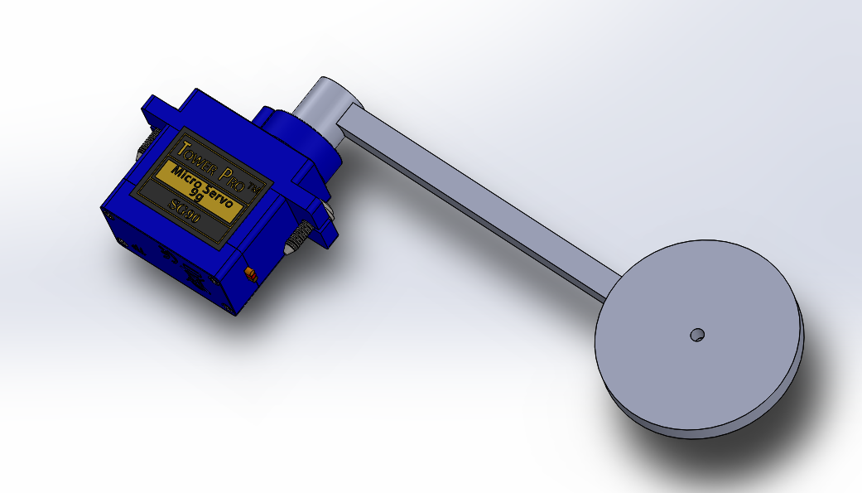

**Design Specifications**

1. Must turn 0-180°
2. Must withstand a ball hit

|  |  |  |  |  |  |
| --- | --- | --- | --- | --- | --- |
| **Specification Number** | **Specification Description** | **Test to perform** | **Relevant requirement** | **Specification [units]** | **Measured**  **Values**  **[units]** |
| **1** | RC Motorturn 0-180° | Degrees Measured | 1 | 180 Degrees | 180 Degrees |
| **2** | Ball hits target with a any speed and doesn’t break | Shoot ball with the flipper at the target and measure the flex degree | 2 | 15 Degrees | 45 Degrees |

**2.3.5.b Pinball RC Servomotor/DC Motor Application Design Cycle: Build**

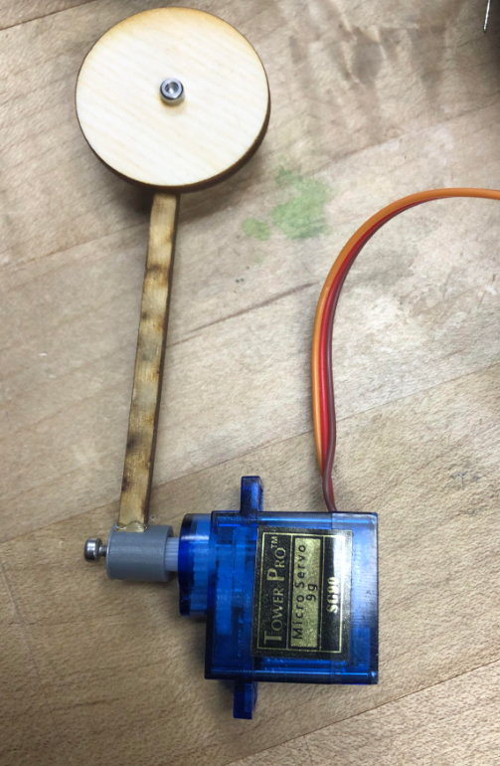

**2.3.5.c Pinball RC Servomotor/DC Motor Application Design Cycle: Test**

Arudino Serial print reads 0-180 degrees and measured with a protractor to confirm angles.

**2.3.5.d Pinball RC Servomotor/DC Motor Application Design Cycle: Assess**

One of the major redesigns is of course making the rod much stronger by increasing the thickness. Also extruding the slot where the rod meets the mount by a greater part and having a screw hole through it and secured with a screw and nut. Also I want to color the target. The hot glue is there to test, but isn’t permanent because the glue shouldn’t be the only thing holding the target up.

**2.3.6 Pinball Flipper Testbed Design Cycle**

Circuit sketch design along with Specifications

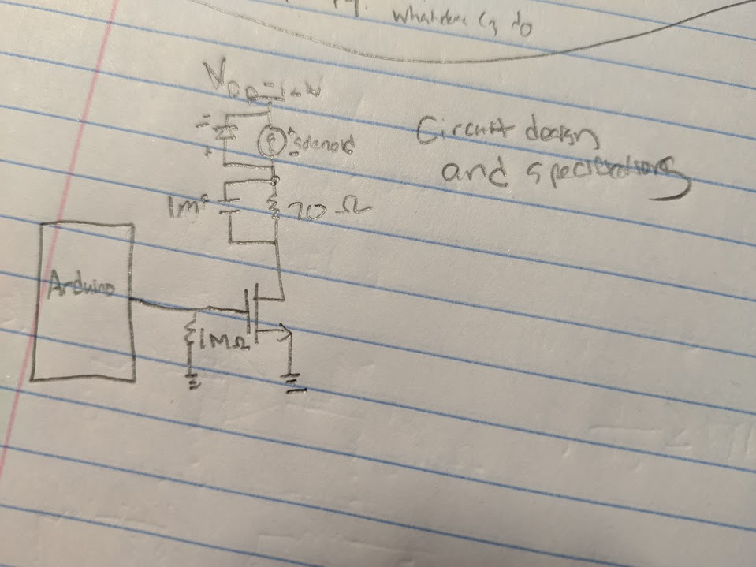

**Design Specifications**

1. Must be powerful enough to launch ball through playfield
2. Must fire consistently

|  |  |  |  |  |  |
| --- | --- | --- | --- | --- | --- |
| **Specification Number** | **Specification Description** | **Test to perform** | **Relevant requirement** | **Specification [units]** | **Measured**  **Values**  **[units]** |
| **1** | Lauch ball far enough | Ball firing test | 1 | distance(in | 15 inches |
| **2** | Flipper fires consistently | FIre flipper quickly | 2 | Flips per sescond | 3 flips per second |

Cad Mechanical Design

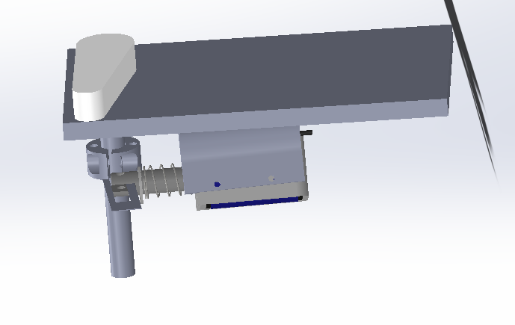

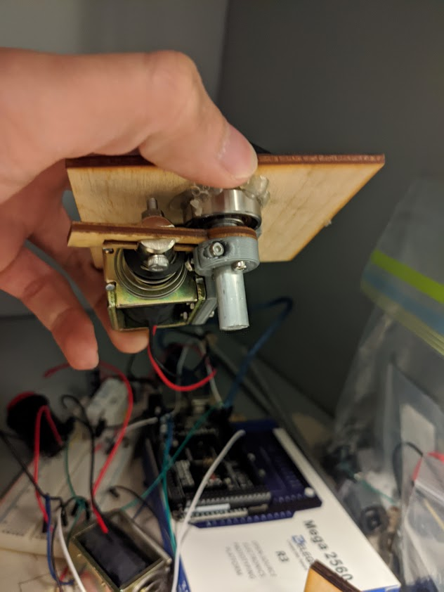

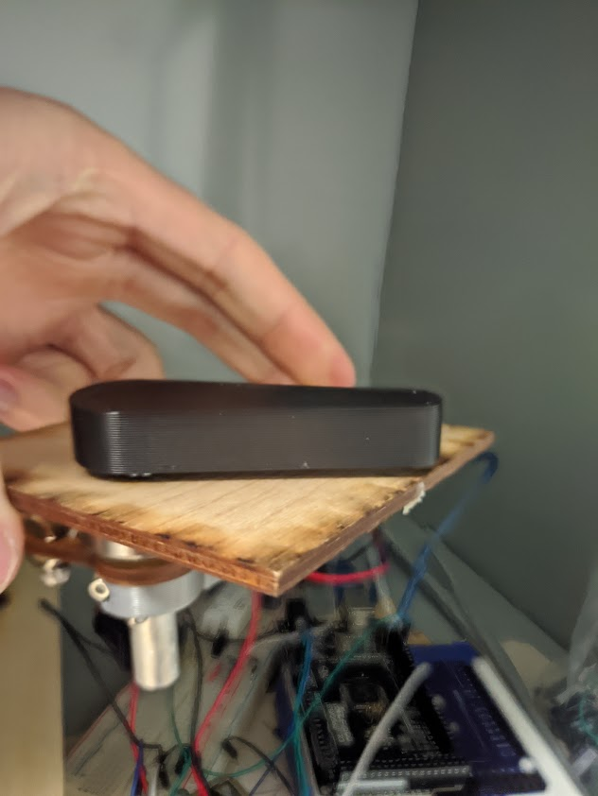

Testing plan and results  
Currently, the system can provide sufficient power to the flipper. However, when the connector piece becomes crooked due to the flimsy piece of wood, the solenoid get stuck.

Redesign notes and analysis

There is currently way too much friction in the system causing a weakened flipper. The plan is to retap the rod so that it is more straight and so that the flipper is parallel to the base plate. Also, our plan is to assemble better as the connector piece is currently a bit crooked causing the solenoid to have to work harder in order to push the flipper.